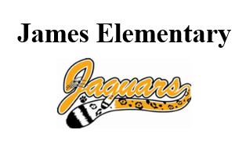**Uniform Policy**

James is a **mandatory uniform school**. Students will wear:

-**gold**, **white** or **black** collared **tops**/polos with

-**black** or **khaki (tan) pants**, shorts or jumpers

Uniforms will also be available in the office, just let us know if we can help.

**Cell Phone/Electronic Devices Policy**

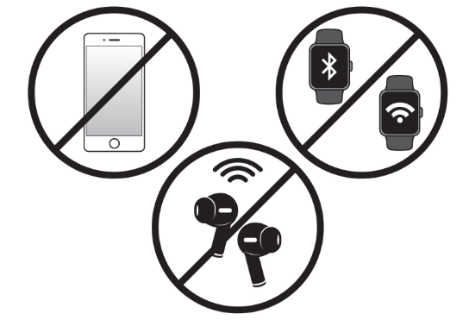For student safety and test security, **students may not take out or use cell phones** (or ear buds or headphones or smart watches) during the instructional day. They must **remain off and out of sight**. This will also prevent these devices from becoming a distraction or unintentionally getting broken or misplaced.

Thank you for your understanding,

Louis Murphy

Principal   
James Elementary

**Uniform Policy**

James is a **mandatory uniform school**. Students will wear:

-**gold**, **white** or **black** collared **tops**/polos with

-**black** or **khaki (tan) pants**, shorts or jumpers

Uniforms will also be available in the office, just let us know if we can help.

**Cell Phone/Electronic Devices Policy**

For both student safety and test security, **students may not take out or use cell phones** (or ear buds or headphones or smart watches) during the instructional day. They must **remain off and out of sight**. This will also prevent these devices from becoming a distraction or unintentionally getting broken or misplaced.

Thank you for your understanding,

Louis Murphy

Principal   
James Elementary